
AMBE ENGINEERS PVT LTD
FARIDABAD
ISO-9001-2015 Certified Company
MANUFACTURER / FABRICATOR
OF
FINISH MACHINED COMPONENTS
REQUIRED FOR
POWER SECTOR-STEAM / HYDRO
STEEL / SUGAR / CEMENT CRUSHERS/MECHANICAL/HYDROLIC PRESES
&
GENERAL ENGINEERING PURPOSE

COMPANY PROFILE
1. Name : AMBE ENGINEERS PVT. LTD.
2. Postal Address : Corporate - Office
C- 63, Sector – 11, Faridabad- 121006, Haryana.
Phone: (O) 0129- 2222092, 4017023, (Fax) 0129-4008206
: Works
Plot No-2, Last block, Road No. W-8
Saroorpur , Industrial Area, Sohna Road,
Ballabgarh- 121004, Haryana.
Phone : 0129-2235045
Email: ambe_best@rediffmail.com,
3. Year of Establishment : 2009
4. Directors : Mr. V.K. Gupta (M) 09899927736, 09311127736
email: md@aeplfbd.com
Mrs. Sandhya Gupta
5. Bankers : Punjab National Bank - Ballabhgarh
HDFC bank -Faridabad
6. Work-Area : 48000 ft ²
Covered area: 39,900 ft ² (six sheds)
7. Manufacturing : We undertake fabrication, finish machining and assembly
of all types of heavy/ light close tolerance engineering
components.
8. Certification By : ISO-9001:2015- IAS
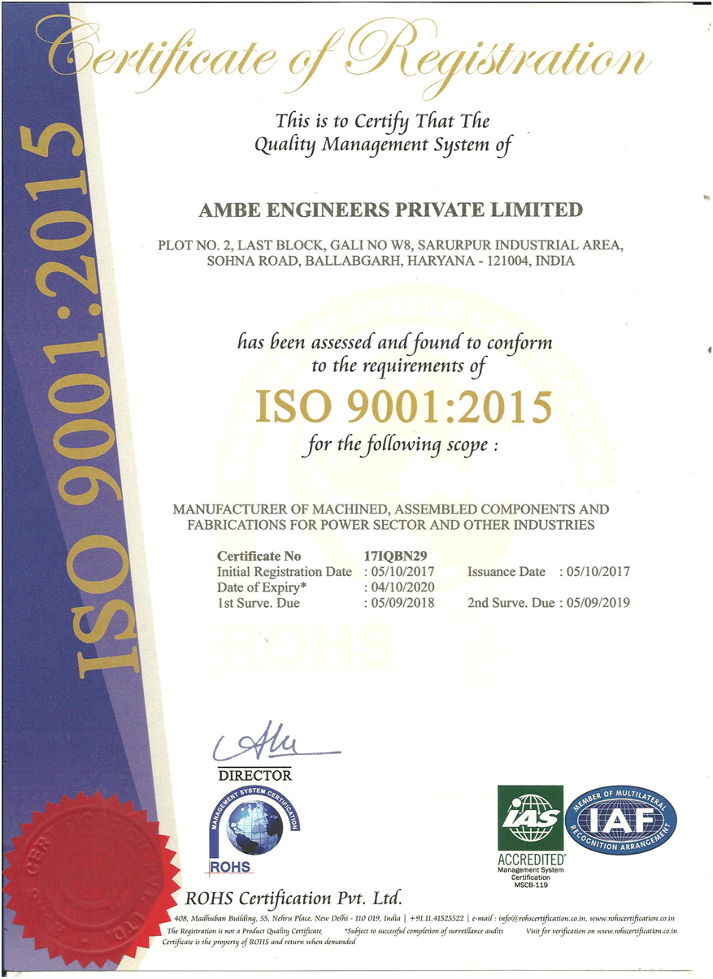
Details of Machines
A. MACHINING CENTERS
Name of machine Make Capacity
1. 4-Axis-Vertical Machining Center (VMC) BFW Stroke Size:-1250X610X610 mm
with Rotary Chuck Ø250 mm Table Size : 1400 x 600 mm
Accuracy: 3μ (0.008 mm)
2. 3-Axis-Vertical Machining Center (VMC) BFW Stroke Size:-1600X910X810 mm
Table Size: 1900 x 700 mm
Accuracy: 5 μ (0.007 mm)
3. 3-Axis -Vertical Machining Center (VMC) BFW Stroke:-1250X610X610 mm
Table size :1400 x 600 mm Accuracy : 3 μ ( 0.006 mm)
4. 4-Axis-Vertical Machining Center (VMC) BFW Stroke:- 3200X2200X 920 mm
With Universal Head Table Size : 3000 x 2000 mm
Accuracy: 13μ (0.013 mm)
5. 3-Axis-Vertical Machining Center (VMC) KAFO Stroke size: 3000X2000X 810 mm
Table Size : 3000 x 2000 mm
Accuracy: 18μ (0.018 mm)
6. CNC Horizontal Boring Machine TOS-WHN 13a Spindle Dia-130mm
Table Size: 1800x1800 mm
Horizontal Travel-3500 mm
Cross Travel: 1200+1000mm
Vertical Travel-2000mm

B. BORING MACHINES
1. Horizontal Boring Machine TOS W-100 Spindle Dia : 100mm
with DRO Table Size: 1250 X 1250 mm
Qty :- (2 nos. ) Horizontal Travel: 1750mm
Cross Travel: 1650mm
Vertical Travel: 1200mm
Accuracy: 20 μ (0.02 mm)
2. Horizontal Boring Machine TOS H-100A Spindle Dia : 100mm
with DRO Table Size:1250 X 1250 mm
Horizontal Travel: 1750mm
Cross Travel: 1650mm
Vertical Travel: 1200mm
Accuracy: 20 μ (0.02 mm)
3. Horizontal Boring Machine WMW Spindle Dia : 125mm
with DRO Table size :1900 X1600mm
Horizontal Travel: 2000 mm
Cross Travel: 1650 mm
Vertical Travel: 1600 mm
Accuracy: 40μ (0.04 mm)
4. Horizontal Boring Machine WMW Union Spindle Dia: 80mm
with DRO Table Size :1000x1170 mm
Horizontal Travel: 1600 mm
Cross Travel: 1000 mm
Vertical Travel: 1000 mm
Accuracy: 20μ (0.02 mm)

6. Vertical Boring Machine Stanko-Russia Table dia : 2100 mm
Swing: 2350 mm
Height: 2200 mm
Accuracy: 20 μ (0.02 mm)
7. Vertical Boring Machine Webster & Bennett Ltd Table Dia. : 1200 mm
with DRO Coventry-England Swing : 1300 mm
Height: 650 mm
Accuracy: 20 μ (0.02 mm)

C. LATHE MACHINES
1. Heavy Duty Lathe Leo Poldo-Italy Max Swing : 900 mm,
Center to center dia. :600mm
Max. Length: 5000mm
Accuracy: 5 μ (0.005mm)
2. Lathe with DRO GAMET-England Max. Swing: 300 mm
Center to center dia.: 270mm
Max .travel: 1800mm
Accuracy: 4 μ (0.004 mm)
3 . Conventional Lathe HMT Turning between centers:
1200 mm
Swing over bed: 450mm
Swing over cross slide:
350mm
Accuracy: 40 μ (0.04 mm)
D. GRINDING MACHINES
1. Die Grinders Bosch 25,000rpm ( Variable speed )
Qty. 4nos.
2. Tool Grinder Wolf Wheel dia :150 mm
3. Hand Grinding Machines Bosch Wheel dia : 125 mm
Qty. 25 nos Dewalt Wheel dia :125 mm
Qty. 10 nos. Dewalt Wheel dia :180 mm
4. Polisher Dewalt Speed: 3500rpm
Qty. 2nos.
5. Flexible X-Shaft Grinder Perfect HP (3-ф) Wheel dia. 4 -7 inches

6. Surface Grinder SEEDTEC -TAIWAN Table Size :600mmX300mm Accuracy : 2 μ (0.002 mm )
E. OTHER -MACHINES
1. Chop Saw Dewalt Model D 871
2. Radial Drilling Machine MAS-VO50M 60mmX1600 mm
with DRO Accuracy : 10 μ ( 0.01mm)
3. Hand Drill Machine Bosch capacity: 15mm
4. Reciprocating Compressors Ingersoll Rand 10HP
SR make 7 HP
5. Mechanical Press Rattan Engg 75 Ton
6 . Drill and TAP Machine 5 Nos

F. WELDING –MACHINES-Fabrication
1. Tig Welding Machine -1 No Inverter Type 400Amps/200Amps
2. Mig Welding Machine - 9 No Diffusion /ESAB /VWT 400Amps
3. ARC Welding Machine -7 No Inverter Type 400Amps
4. PUG M/C- 1No ESAB
5- Gas Cutters- 8 Nos
6- Plasma /Oxy-Acetylene-CNC Cutting M/c Messers 3000 x 16000 mm
Plasma:- 20mm
Oxy Cutting Thk.-300mm
G. WORK- HANDLING FACILITIES
1. E.O.T. Crane: 15 ton- 3 No
2. E.O.T. Crane: 10 ton -1 nos
3. E.O.T. Crane: 5 ton - 2 nos

H. DEDICATED POWER SUPPLY
Power Rating
1. 125 KVA Generator Cummins 2009-10
2. 200 KVA Electrical Transformer Connected Load-105 KVA

- LIST OF MEASURING INSTRUMENTS
PARTICULARS | RANGE | LEAST COUNT | MAKE | QTY
Inside Micrometer | 50-1500 mm | 0.01mm | Mitutoyo | 1 no
Out Side Micrometer | 0-25 mm | 0.001mm | Insize -USA | 1 no
Out Side Micrometer | 0-25 mm | 0.01mm | Mitutoyo | 1 no
Out Side Micrometer | 25-50 mm | 0.01mm | Mitutoyo | 1 no
Out Side Micrometer | 50-75 mm | 0.01mm | Mitutoyo | 1 no
Out Side Micrometer | 75-100 mm | 0.01mm | Mitutoyo | 1 no
Out Side Micrometer | 100-125 mm | 0.01mm | Mitutoyo | 1 no
Out Side Micrometer | 125-150 mm | 0.01mm | Mitutoyo | 1 no
Out Side Micrometer | 150-300 mm | 0.01mm | Mitutoyo | 1 no
Out Side Micrometer | 300-400 mm | 0.01mm | Mitutoyo | 1 no
Out Side Micrometer | 400-500 mm | 0.01mm | Mitutoyo | 1 no
Out Side Micrometer | 500-600 mm | 0.01mm | Mitutoyo | 1 no
Out Side Micrometer | 700-800 mm | 0.01mm | Mitutoyo | 1 no
Out Side Micrometer | 800-900 mm | 0.01mm | Mitutoyo | 1 no
Out Side Micrometer | 900-1000 mm | 0.01mm | Mitutoyo | 1 no
Vernier Caliper | 0-150 mm | 0.02mm | Mitutoyo | 1 no
Vernier Caliper | 0-150 mm | 0.02mm | Insize-USA | 1 no
Vernier Caliper | 0-300 mm | 0.02mm | Mitutoyo | 1 nos
Vernier caliper | 0-300 mm | 0.02 mm | Insize-USA | 4 no
Vernier Caliper | 0-300 mm | 0.02mm | Trusize-USA | 3 nos
Digital Vernier Caliper | 0-300 mm | 0.01mm | Mitutoyo | 1 no
Digital Vernier Caliper | 0-300 mm | 0.01mm | Trusize | 1 no
Vernier Caliper | 0-600 mm | 0.02mm | Insize- USA | 1 no
Vernier Caliper | 0-1000 mm | 0.02mm | Mitutoyo | 1 no
Vernier Caliper | 0-1500 mm | 0.02 mm | Insize-USA | 1 no
Depth Gauge | 0-300 mm | 0.02mm | Mitutoyo | 1 no
Bore Gauge | 18-35 mm | 0.01mm | Mitutoyo | 1 no
Bore Gauge | 35-60 mm | 0.01mm | Mitutoyo | 1 no
Bore Gauge | 50-150 mm | 0.01mm | Insize | 1 no
Bore Gauge | 50-150 mm | 0.01mm | Mitutoyo | 1 no
Bore Gauge | 160-250mm | 0.01mm | Mitutoyo | 1 no
Bore Gauge | 250 – 400 mm | 0.01 mm | Insize | 1 no
Dial Indicator | 0-10 mm | 0.01mm | Mitutoyo | 3 nos
Dial Indicator | 0-10 mm | 0.01mm | Baker | 2 no
Dial Indicator | 0-10 mm | 0.01mm | Insize USA | 5 nos
Dial Indicator | 0-10 mm | 0.01mm | Mito-China | 1 no
Dial Indicator | 0-9 mm | 0.01mm | Mitutoyo | 1 no
Dial Vernier Caliper | 0-300 | 0.02mm | Mitutoyo | 1 no
Puppy Dial | 0-1 mm | 0.01mm | Mitutoyo | 1 no
Puppy Dial | 0-1 mm | 0.01mm | Inside USA | 2 nos
Bevel Protector | 0 – 360⁰ | 1’ | Mitutoyo | 1 no
Dial Indicator | 0-1mm | 0.001mm | Mitutoyo | 1 no
Height Gauge | 0-1000mm | 0.02mm | Mitutoyo | 1 no
Point Micrometer | 0-25mm | 0.01mm | Mitutoyo | 1 no
Point Micrometer | 0-25mm | 0.01mm | Insize-USA | 2 nos
Pistol Caliper | 0-80mm | 0.1mm | Baker | 1 no
Hardness Tester | Digital | Compatible For BHN/HRC/HRB/HV | Sanchi | 1 no
Surface Roughness Tester | Digital | 0.1µm | Mitutoyo | 1 no
Thread Plug Gauge | M 20X2.5 |  | BAKER-HIP | 1 no
Thread Plug Gauge | M30 |  | TRUTHREAD | 1 no
Thread Plug Gauge | M36 |  | TRUTHREAD | 1 no
Thread Plug Gauge | M42 |  | TRUTHREAD | 1 no
Thread Plug Gauge | M16X2 |  | BAKER-HIP | 1 no
Thread Plug Gauge | M16X1.5 |  | BAKER-HIP | 1 no
Thread Plug Gauge | M12X1.75 |  | BAKER-HIP | 1 no
Thread Plug Gauge | M10X1.5 |  | BAKER-HIP | 1 no
Thread Plug Gauge | M6X1 |  | BAKER-HIP | 1 no
Thread Plug Gauge | M5X0.8 |  | BAKER-HIP | 1 no
Thread Plug Gauge | 3½ inch NPT |  | TRU THREAD | 1 no
Thread Plug Gauge | 3 inch NPT |  | TRU THREAD | 1 no
Thread Plug Gauge | 1½ inch NPT |  | TRU THREAD | 1 no
Thread Plug Gauge | 1½ inch RC |  | TRU THREAD | 1 no
Thread Plug Gauge | 2 inch RC |  | TRU THREAD | 1 no
Thread Plug Gauge | 3½ 8UN | GO-NO GO | TRU THREAD | 1 no
Coating Gauge Thickness | Digital | 1000 microns | Insize | 1 nos

J- FUTURE EXPANSION PLANS
1. CNC Vertical Turning Lathe Table dia. 2500 mm,
Swing.3000mm,
- height
2. Press Brake (Under Installation) 120Ton * 3000mm
K. LIST OF CUSTOMERS
INDUSTRY COMPONENTS DEIVERED
1. L&T MHI-Surat - Steam Turbine Blades ,Misc. Components of
Steam Turbines
2. BHEL- Govindwal - Spiral Wound Gaskets
3. BHEL- Varanasi - Sealing Rings, Misc. Components of Steam
Turbine
4. M/S PCI-Manesar - MOP Casings/Misc. Components for Steam
Turbine
5. BOOM Hydro Energy Pvt. Ltd. - Frances Runner Blades, Kaplan
Palwal (vil.) Metrol Blades ,Hydro Turbine components
6. Dynamic power services – Housings,High Pressure casing/ cover,
Haridwar Liners etc.
7. Isgec Heavy Engg. Ltd. Bawal- Fly wheels,Cylinders,
Mechanical Press
Components
8. Flovel Energy Pvt Ltd- Faridabad- Hydro Turbine components
9. Propel Industries Pvt Ltd-Coimbatore- Fabrication of Crushers
Items
10. Sandvik Asia Pvt Ltd- Gurgaon- Fabrication Of Crusher
Components
11. Humboldt India Pvt Ltd-Faridabad- Machining of Critical
Components.
12. JBM
13. TIL LTD.
14. Terex
And Many More…

